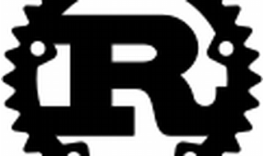

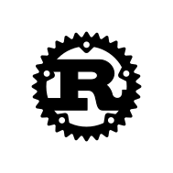

Explore

**Rust** is a multi-paradigm, general-purpose programming language that emphasizes **performance**, **type safety**, and **concurrency**. [It enforces **memory safety**—meaning that all references point to valid memory—without a garbage collector1](https://en.wikipedia.org/wiki/Rust_%28programming_language%29).

Here are **five free resources** to learn Rust:

1. **The Rust Programming Language (The Book)**: This comprehensive resource provides an overview of Rust from first principles. You’ll build projects and gain a solid grasp of the language. [Read the Book!](https://www.rust-lang.org/learn)
2. **Rustlings**: A hands-on course that guides you through setting up the Rust toolchain and teaches you the basics of reading and writing Rust syntax on the command line. [Do the Rustlings course!](https://www.rust-lang.org/learn)
3. **Rust By Example**: If you prefer learning through code examples, Rust By Example showcases practical code snippets with minimal explanations. It’s a great way to dive into Rust. [Check out Rust by Example!](https://www.rust-lang.org/learn)
4. **Rust Documentation**:
   * **Core Documentation**: Explore the core features of Rust.
   * **Standard Library Guide**: Learn about Rust’s standard library APIs.
   * **Edition Guide**: Understand the different Rust editions.
   * **Cargo Book**: Dive into Rust’s package manager and build system.
   * **rustdoc Book**: Create documentation for your Rust crate.
   * **rustc Book**: Familiarize yourself with the Rust compiler.
   * **Compiler Error Index**: Detailed explanations of Rust compiler errors.
5. **Application Domain-Specific Learning**:
   * **Command Line Book**: Learn to build effective command line applications in Rust.
   * **WebAssembly Book**: Use Rust to create browser-native libraries through WebAssembly.
   * **Embedded Book**: Master Rust for microcontrollers and other embedded systems.

Happy learning! 🚀🦀